***WATER QUALITY REPORT***

**PWS# OH5900112 Water testing performed in 2016**

*The Village of Cardington has an unconditional license to operate a water plant.*

## ***continuing our commitment to you***

We are pleased to provide you with this year’s Annual Water Quality Report. This edition covers all testing completed from January 1 – December 31, 2016. As in the past, we are committed to deliver to you the best quality drinking water possible and remain diligent in our goal to improve the quality and dependability of water to you, our customers. For more information regarding this report, or for any other questions relating to your drinking water, please contact:

Danny Wood, Village Administrator (419) 864-7607.

## ***Where Does My Water Come From?***

Our water source is from two wells located on Newman-Cardington Road in Marion County. The well site is approximately 9 miles southwest of the treatment facility located at 120 East Williams Street in the Village of Cardington. The aquifer that supplies water to the Village of Cardington has a low susceptibility to contamination, due to the low sensitivity of the aquifer in which the well is located. This does not mean that this well field cannot become contaminated, only that the likelihood of contamination is relatively low. In 2005, The Village acted to protect their water source by purchasing the 17.5-acre parcel on which the well site is located. The Village also has an emergency connection with Del-Co Water, Inc. that can be activated if the need should arise.

***HOW IS THE WATER I DRINK TREATED?***

The water treatment facility removes hydrogen sulfide by oxidation and filtration. The filtered water is softened using an ion-exchange process which uses salt to soften the water. The softened water is disinfected with chlorine prior to distribution to customers. Groundwater is water located underground and typically requires less treatment than water from lakes, rivers or streams. The wells that supply the water for the Cardington residents are drilled 180 feet deep into limestone bedrock on Newman-Cardington road in Marion County. Chlorine is injected into the water at the well site as a method of pretreatment. After a nine-mile journey through a ten-inch pipe line, the water goes through an aerator, and then into detention tanks. From the detention tanks, using low service pumps, the water treatment process begins. The water treatment process is when the water is pumped through pressure filters and then through water softeners. Phosphate and chlorine are injected into the water as it goes into the clear well. The clear well is a 250,000-gallon tank (about one day’s supply) that stores the water until needed. The clear well is constantly being filled by the low service pumps. Then the high service pumps begin pumping the water from the clear well into the distribution system. The distribution is a maze of pipes that circulate the  water throughout the Village, including the tower. 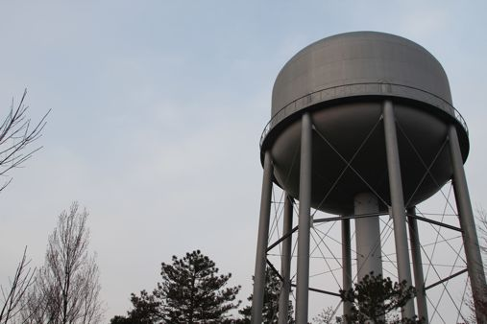 Our tower holds 300,000 gallons and is important to the process because it is another source of storage, but most importantly, the tower maintains the water pressure throughout the Village. A good water supply is important so that all of the Village residents have water to meet their needs, but also in the event of a fire, the Fire Department has the water pressure needed to handle ANY emergency. This process is done daily to provide you with the good quality water you enjoy every day.

